Earth Science 100: The Earth as a System

Ice Ages and Global Climate: Gateway’s to Glaciations

The focus of this course segment is to investigate how and why earth’s climate has changed over the last few million years and to get a general understanding of the types of evidence scientists use to look at earth’s climate. To do this, each student will be preparing for a scientific cruise aboard the JOIDES Resolution (sorry, this is a virtual trip via CD-ROM). The scientific objective of the cruise is to determine the cause of the onset of the most recent northern hemisphere glaciation, which began approximately 3 million years ago.

Background:

The record of earth’s climate has been studied in great detail. Through the Mesozoic Era (Age of Dinosaurs) and into the Tertiary, earth’s climate was much warmer than today with balmy conditions in high latitudes. Beginning about 36 million years ago, a cooling trend began, which led up to onset of the Northern Hemisphere glaciation about 3 million years ago. The cooling was not a smooth trend, but saw ups and downs along the way.

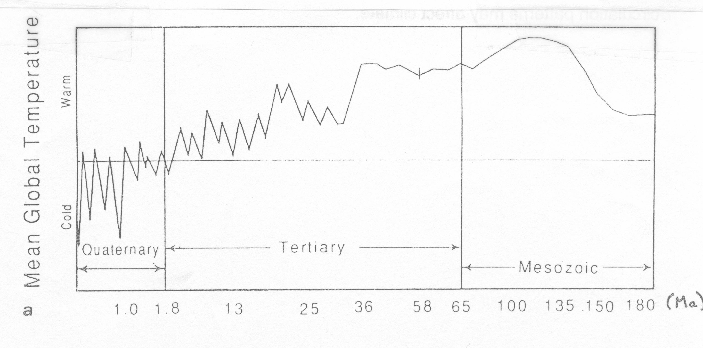
Schematic diagram of the planetary cooling trend in the Cenozoic. From Seibold & Berger, 1996.
Recent history shows that the earth has gone through several “glacial” and “interglacial” periods on a regular basis, beginning approximately 800,000 years ago. During this time, the earth has experienced glacial conditions every 100,000 years, with the Last Glacial Maximum at 18,000 years ago. From approximately 2.5 to 1 million years ago the earth experienced less extreme cycles, but on a period of approximately 41,000-year cycle. A hypothesis to explain these cycles was originally proposed by Milutin Milankovitch in the 1930’s. He suggested that regular variations in the Earth’s orbital motions could cause a succession of ice ages separated by warm periods. Such variations would cause long-term fluctuations in the radiation received from the Sun during summer seasons in the high latitudes of the northern hemisphere, and control the occurrence of ice ages. Because these orbital variations have occurred over much of Earth’s history, these variations alone cannot have been the trigger to the most recent glaciations. What other factors influence climate? What evidence can scientists gather to study such a question? Welcome aboard!

Shipboard Investigations:
- Describe the source of ice-rafted debris (IRD) ocean sediments. Explain the significance of changes in amounts of IRD in sediment cores.
- Explain how changes in Earth’s magnetic field have allowed scientists to develop the Geomagnetic Polarity Time Scale (GPTS). Apply the GPTS to determine age information in sediment cores.
- Explain the difference between ¹⁶O and ¹⁸O isotopes. Discuss how the differences in the ratio of these two isotopes can be used to reconstruct information about global ice volume, sea level, and seawater temperatures.
- Discuss how changes in the assemblage of microfossils can be used to determine changes in ocean circulation patterns.
- Discuss how tectonic processes and changes in Earth’s orientation and ocean circulation patterns may affect climate.

